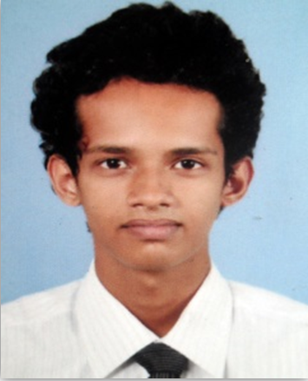

|  |  |  |  |  |  |  |  |
| --- | --- | --- | --- | --- | --- | --- | --- |
| |  | | --- | | **NISAL MANURA PERERA No.772/C Pannipitiya Road, Pelawatta, Battaramulla.**  **077-5354174**  **nisal.manura@hotmail.com** |   Carrier Objective  **Vision**  Become a senior logistics or marketing manager for a blue-chip company.  **Mission**  Perform at the maximum capacity, give the best of myself to the company, lead others by example and always be ethical.  Education  ***YEAR 2011***  **IGCSE Ordinary Level London Examination:** 5 GCSE’s at B and above including Mathematics and English Language.  ***YEAR 2013***  **GCE Advanced London Level Examination** :   |  |  | | --- | --- | | Accounting | A | | Pure Mathematics | B | | Economics | C |   ***YEAR 2014***  **Undergraduate at University of West of England – Bachelor’s Degree on Business Administration**  Relevant Skills  **Language Skills** : Fluent in English and Sinhala  **Strengths** : Good interpersonal and communication skills, managing people, quickly grasp business opportunities and a good team worker.  Interests and Achievements  **Accomplishments**  Deputy Head Prefect of Willesden College International 2013 after two years of experience as a senior prefect in the prefects’ guild. Involved in charity services and special event organizing at high school as a leader of the guild. Improved skills on decision making by strategic thinking, identifying opportunities, problem solving and working under rules and regulations.  House Sports Captain of Willesden College International after representing the athletics squad and the cricket team for a couple of years as the captain. Developed managing skills and presumed effective planning systems.  Senior School Band Member at Willesden College International during the year 2009, 2010 and 2011. Participated in School Band Competitions and was an instrument player at the School Band Show (Starry Night of Willesdenites 2011). Recognized opportunities in complex situations and self-confidence.  Awards for English Literature, English Language, Mathematics, Business Studies & Essay Writing. Golden Awards and Participation Awards at World Math Day & World Literature Day and many other awards in Art Competitions, Inter-School and Inter-House Events. Participated in meets conducted by the ministry of sports and youth affairs, Sri- Lanka.  **Extra-Curricular Activities**   * 1. Cricket - Represented the Under 15 School Cricket Team (2007/2008)   2. Football - Represented the School Soccer Team (2008/2009)   3. Swimming - Participated in Inter-school meets and sports development projects.   4. Basketball - Represented the house team (2011/2012/2013)   5. Badminton - Represented the house team (doubles open event – 2013)   6. Athletics - Represented the house squad (2012/2013) |